Export Control



Balancing and

Diagnostic Systems

**SCHENCK RoTec GmbH**

**Declaration of Export Restrictions**

|  |  |  |
| --- | --- | --- |
| Your Invoice / Purchase order no.: |  | Refer to Annex Section **A** |
| Our Purchase order no.: |  | Refer to Annex Section **B** |
| Your vendor no.: |  | Refer to Annex Section **C** |
| Material denomination: |  | Refer to Annex Section **D** |
| Schenck RoTec Material no.: |  | Refer to Annex Section **E** |

**Please complete the following and / or delete if not applicable:**

1. Is the product subject of Annex I to the German Foreign Trade and Payments Ordinance?

If YES, then please tell us the entry in the Export Control List under which the product is specified:

Export Control List entry:  (If NO, please cross out this section)

1. a) Is the product subject of any annex to the EC Dual-Use Regulations?

If YES, then please tell us the entry in the Annex under which the product is specified:

EC Dual-Use Annex entry:  (If NO, please cross out this section)

1. b) Is the product subject of any annex to EC Regulation 267/2012 (Iran) or of any update of this regulation?

If YES, then please tell us the entry in the Annex under which the product is specified:

EC Regulation 267/2012 Annex entry:  (If NO, please cross out this section)

1. Is the product subject to Export Administration Regulations (EAR) and registered in Commerce Control List (CCL)?

If YES, then please tell us the Export Control Commodity Number (ECCN) under which the product is specified:

ECCN:  (If NO, please cross out this section)

1. Please designate the percentage of US parts contained or incorporated in your products:

NO US parts  US percentage less than 10%  less or equal 25%  more than 25%

1. Please designate the Statistical Commodity No. (HS classification code) appropriate for your product:

Statistical Commodity No. (HS classification code):

1. Please designate the Country of Origin appropriate for your product:

Country of Origin:

1. Please designate the Net Weight appropriate for your product:

Net Weight:

**Please complete the form with Location, Date, Company Stamp, Name and legally binding Signature!**

……………………………………………………………………………………………………………………………

(Location, Date, Company Stamp, Name in printed letters and legally binding Signature)

**Annex: Explanations to complete the form**

You are probably aware of the fact, that exported and re-exported goods are subject to applicable German, European und US regulations which are strictly to be observed.

For organizational reasons it is not possible to include all required general information in any Quotation, Order conformation, Invoice and Shipping document. Therefore we ask you to forward the following information by utilizing the enclosed form with regard to items and products respectively which are inquired / ordered from your company.

The following is an explanation how to fill out the form correctly. You will find most of the data regarding **A** to **E** also in eMail or other correspondence. Please transcribe the information to the form as shown below.

To **A** Please write down YOUR Invoice or Purchase Order Confirmation No.

To **B** Please transcribe OUR Purchase Order No. from our Purchase Order Document (see below).

To **C** Please transcribe YOUR Vendor No. from our Purchase Order Document (see below).

**Example regarding B and C:**

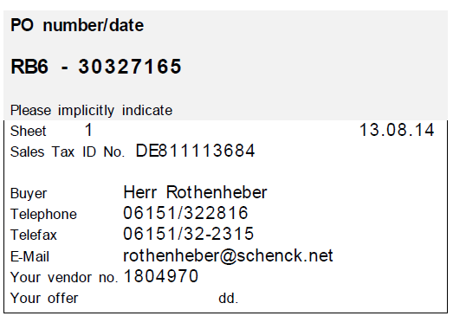

**B**

**C**

To **D** Please provide us with a short description of your Material Denomination, Material No., Type No., etc.

**Example regarding D:** Belt Drive Assembly 4/5UBD, Material No. 123456 or Type No. ABCDEF

To **E** Please transcribe OUR Material No. from our Purchase Order Document (see below).

**Example regarding E:**

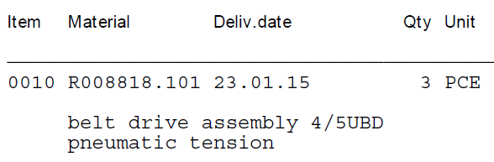

**E**

If you have further questions regarding the form, please do not hesitate to contact us.